2026国际学生研究生招生简章

ADMISSION BOOK FOR INTERNATIONAL STUDENTS
POSTGRADUATE PROGRAMS

Introduction to Beijing University of Chemical Technology
Founded in 1958, Beijing University of Chemical Technology (BUCT) is a national key university affiliated with the Ministry of Education of the People’s Republic of China. A member university of China's "211 Project", "985 Project Innovation Platforms" and “Double First-Class University Project". BUCT shoulders the mission of innovative talent training, scientific research, and high-tech development.
Over the past 68 years, through continuous efforts, BUCT has grown into a comprehensive multidisciplinary university rooted in science and engineering and enriched by distinctive disciplines such as business, economics, law, literature, philosophy, education, and medical science. It offers a complete talent development pathway from undergraduate to doctoral levels. In the Essential Science Indicators (ESI) rankings, chemistry, material science and engineering are among the top 1‰ in the world, computer science, environment/ecology, biology/biochemistry, geoscience, agricultural science, physics, Pharmacology & Toxicology, top 1%. The scientific research of BUCT has been in robust development in recent years. Its science and technology funds continue to hit record highs.
With 18 colleges and schools, BUCT is the home university of 16,000 full-time undergraduate students, 10400 full-time postgraduate students (including 2,000 PhD students), 2,700 students of continuing education, and around 400 international students. It hosts more than 2,700 faculty members and staff including 8 academicians from the Chinese Academy of Science and the Chinese Academy of Engineering and 5 international academicians.
With a global vision, BUCT has successively established partnerships with over 170 institutions all over the world. It offers a wide range of education programs to international students including bachelor's, master's and doctoral programs in Chinese and English, Chinese language and culture programs, and summer science camps. It runs around 90 study abroad programs, including exchange programs, joint degree programs, overseas training programs and summer/winter camps. BUCT constantly supports international research collaborations, which have generated abundant high-level research publications in top academic journals. It also hosts a wide range of international conferences and competitions.
The 21st century presents both unprecedented opportunities and profound challenges. Upholding its motto — “to be ambitious, virtuous, profoundly learned, and to serve people” — BUCT is committed to becoming a world-class university distinguished by its unique character and global influence.

Postgraduate Programs
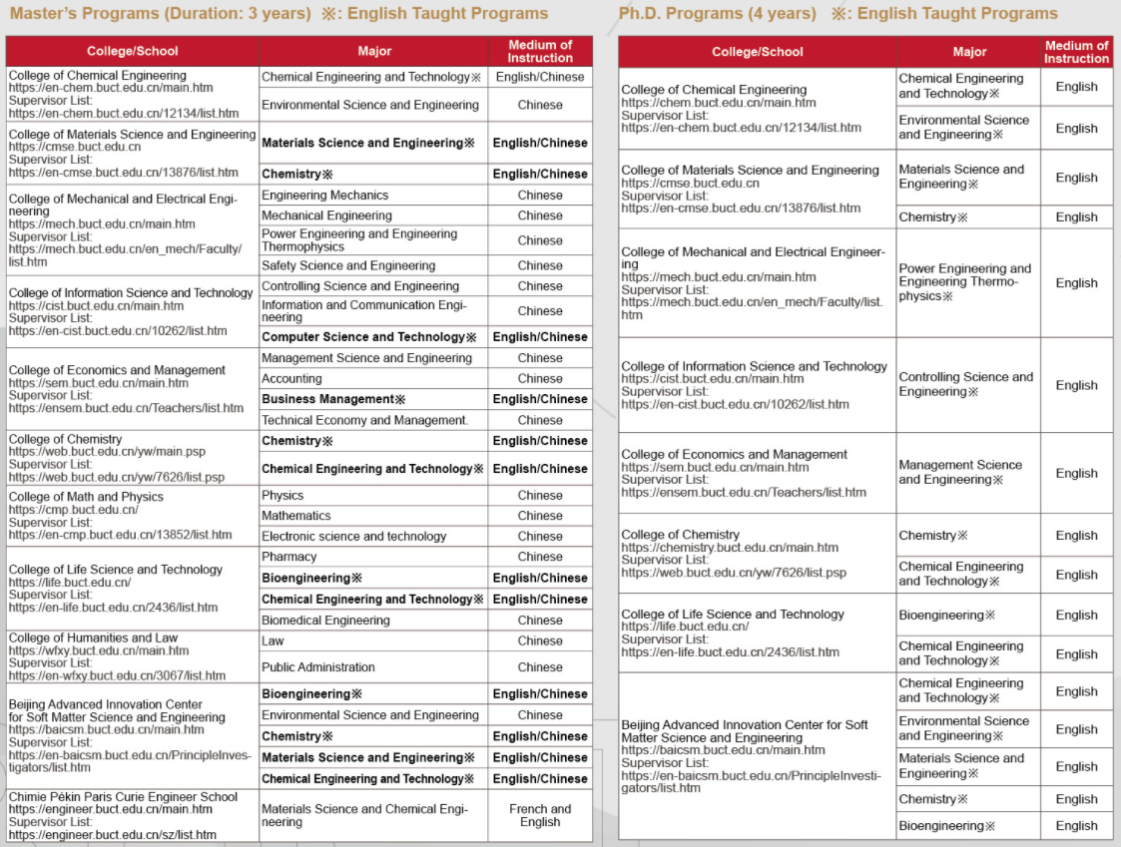

Qualfications of Applicants
- Be non-Chinese citizen with a valid private passport; observe Chinese Laws and regulations of Beijing University of Chemical Technology;
2. Be an academically excellent holder of a bachelor’s degree or its equivalent under the age of 35;
3. Be an academically excellent holder of a master’s degree or its equivalent under the age of 40;
4. Language certificate (per program requirements)
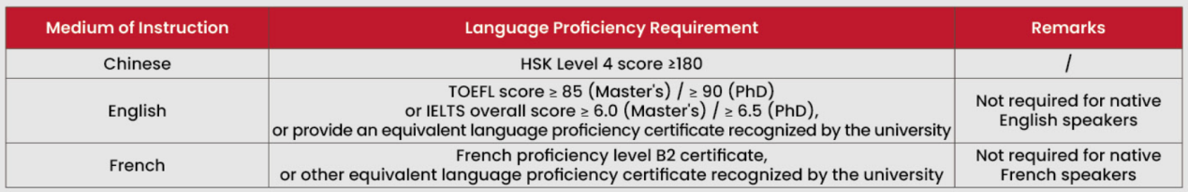
- Applicants with Chinese background must comply with the regulation (JW[2020]No.12) issued by Ministry of Education of the People’s Republic of China.

Application Procedure (Deadline: 30 June 2026)

1. Register an account and activate: http://study.buct.edu.cn, fill out necessary details and upload required materials;

2. Pay the application fee after passing preliminary examination;

3. Comprehensive interview;

4. Pre-admission Announcement (Accepted applicants will be informed via Email.);

5. Receive the Admission Letter and JW201/JW202 Visa Application form.

Note: Please check your email and application platform regularly after submission.

Admission Materials

1. Curriculum Vitae, Personal Statement &Study Proposal (Relevant templates can be found in the Download Section of the BUCT application system);

2. The Photocopy of Passport (Photo page and China visa page if you have);

3. The certified/notarized copy of highest degree’s diploma/certificate of schooling (Undergraduate level and above, if any, in Chinese or English);

4. The certified/notarized copy of highest academic transcript (Undergraduate level and above, if any, in Chinese or English);

5. Two recommendation letters by professors or associate professors;

6. An Acceptance Letter for international Student from BUCT Supervisors;

7. Physical Examination Form for Foreigner;

8. Proof of Chinese or French or English Language Proficiency;

9. Non-Criminal Record in Chinese or English (Issued from local police station);

10. Originals or copies of academic publication, patent, and other academic achievements (If any, priority will be given);

11. Other supporting documents.

Note:

1. Applicants requires an acceptance letter from a BUCT professor and upload it online, otherwise applicants will not be considered as a candidate.

Participating Professors information can be found at the:

2. https://english.buct.edu.cn Click [Faculty]; Search the name of college

3. Applicants are required to upload all materials as above, or else you will not be considered as a candidate.

Fees

Application fee: CNY 500/per person (Only once)

Insurance fee: CNY 800 /year

Residence Permit Charge: CNY 400/year (It is collected by Immigration Bureau)

Tuition fees:

PhD Students: CNY 35,000/year

Master Students (Chinese Instructed): CNY 30,000/year

Master Students (English Instructed): CNY 35,000/year

Accommodation:

Chaoyang Campus: Double room CNY 10,800/semester (CNY 21,600/year, per person)

Changping Campus: Double room CNY 10,800/semester (CNY 21,600/year, per person); Single room CNY 12,600/semester(CNY 25,200/year)

Fee Payment

Notice: Applicants need to pay the fees by bank transfer. The application fee and tuition fee deposit are not refundable after being collected. Only Chinese CNY remittance is accepted, foreign currency remittance is not accepted. Any remittance received in foreign currency will not be processed and will be at the applicant’s own risk.

Payment information

Account name: Beijing University of Chemical Technology

Bank: Bank of Beijing Yinghua Branch

Account number: 01090504300120105029689

Correspondent number: 313100000273

Bank transfer should be accompanied by “Master/PhD Application Fee/Tuition Fee + Nationality + Applicant’s passport name”

Scholarships

Chinese Government Scholarship

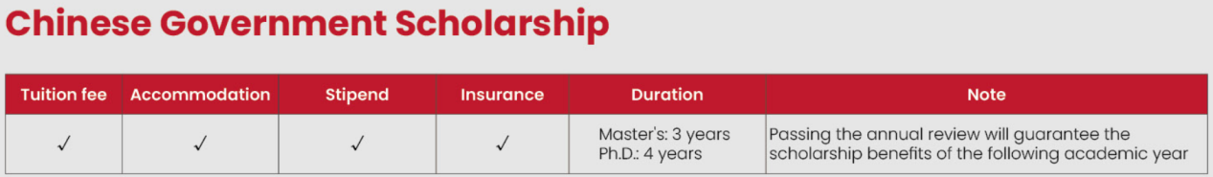

Note: Tution fee, Free university dormitory and stipend will be suspended if students cannot study on-campus.

What does the scholarship cover?

Tuition and accommodation;

Living expenses: Master CNY 3000 / month, Ph.D. CNY 3500 / month;

Comprehensive medical insurance: CNY 800 / year.

How to apply?

Bilateral Program (Type A). The program accords with the cooperation and exchange agreements or consensus reached by the Chinese government and the government sand institutions of other nations.An applicant shall file an application with the dispatching department of their home countries--Chinese Government Scholarship (Type A)

Note: The application time is usually from November to April next year. Please ask for more application information from Chinese Embassy/ Consulate in your home country. When filling in the scholarship application form, the applicant should choose Type A and select Beijing University of Chemical Technology as the first priority institution (The institution code for BUCT is 10010).

University Program (Type B). Including High Level Graduate Program, Silk Road Program,etc--Chinese Government Scholarship (Type B) Applicants must to submit the application to both following website:

BUCT online application system http://study.buct.edu.cn

CSC application system https://studyinchina.csc.edu.cn (The institution code for BUCT is 10010).

Beijing University of Chemical Technology Presidential Scholarship (Ph.D. applicants only)

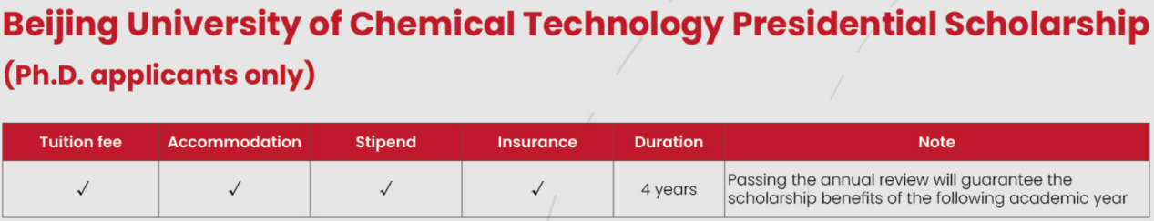

What does the scholarship cover?

Tuition and accommodation;

Living expenses: CNY 3500 / month;

Comprehensive medical insurance: CNY 800 / year.

How to apply?

Register an account and activate in http://study.buct.edu.cn, fill out your application online, BUCT will evaluate applications based on the submitted materials.

The BUCT Presidential Scholarship program only enrolls Ph.D. Students.

Scholarship Deadlines

March 2026 Chinese Government Scholarship

June 2026 BUCT Presidential Scholarship

Note:

Scholarships are highly competitive and more beneficial for those candidates who apply for it in an early time.

Your private passport must remain valid until at least September 2026 when reporting for enrollment.

Please be accurate your personal details when submit the application. The applicant's name, date of birth, passport number, and other details must exactly match the information on the ID page of the passport in order to get the offer smoothly and successfully.

Contact
International Students Office, School of International Education Beijing University of Chemical Technology
No. 15 Bei San Huan East Road, Chaoyang District, Beijing, 100029
Phone: 0086-10-64452461
Email: buctapply@buct.edu.cn
Website: https://english.buct.edu.cn/ English version
Facebook: 北京化工大学 Beijing University of Chemical Technology - BUCT
Instagram: buct.apply
WhatsApp: +86 18811406750
X: BeijingChemical

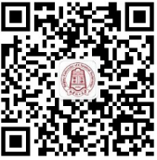 Study in BUCT

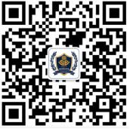 School of International Education



2026国际学生研究生招生简章

ADMISSION BOOK FOR INTERNATIONAL STUDENTS
POSTGRADUATE PROGRAMS
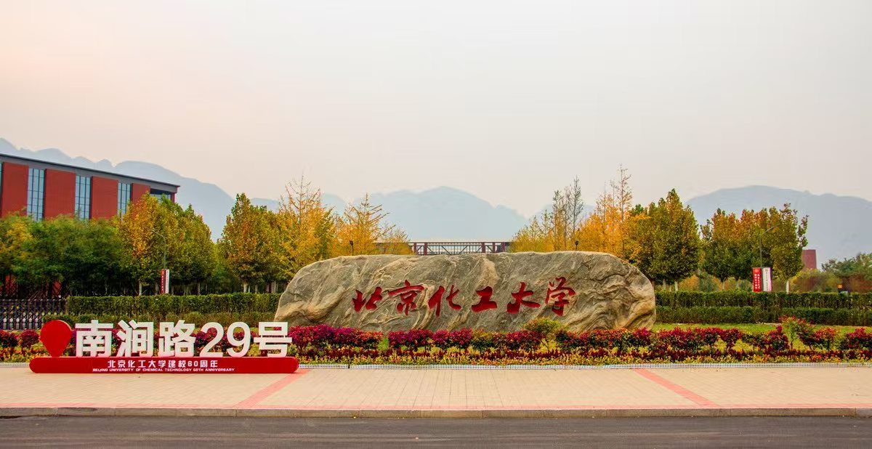
北京化工大学简介
北京化工大学创办于 1958 年，原名北京化工学院，是新中国为“培养尖端科学发展所需的高级化工技术人才”而创建的一所高水平大学。作为教育部直属的全国重点大学，国家“211 工程”和“‘985’优势学科创新平台”重点建设院校，国家“双一流”建设高校，北京化工大学肩负着高层次创新人才培养和基础性、前瞻性科学研究以及原创性高新技术开发的使命。
经过 68 年建设发展，学校形成了“宏德博学、化育天工”的校训和“团结奉献、艰苦奋斗、务实力行、博学创新”的化大精神。目前，学校已发展成为一所理科基础坚实，工科实力雄厚，管理学、经济学、法学、文学、教育学、哲学、医学等学科富有特色的多科性重点大学，形成了本科教育、研究生教育、国际学生教育、继续教育等多层次人才培养格局。现有 18 个院（系），在校全日制本科生 16000 余人，研究生 10400 人（其中博士 2000 余人），函授、夜大等继续教育学生 2700 余人，学历留学生近 400 人。教职工 2700 多名，其中包括 8 名中国科学院院士和中国工程学院院士及 5 名国际院士。
学校学科实力稳步增强，“化学工程与技术”入选国家“双一流”建设学科，在国家第五轮学科评估中 A类学科取得显著突破。化学、材料科学、工程学居 ESI 排名前 1‰，化学、材料科学、工程学、生物学与生物化学、生态 / 环境学、计算机科学、农业科学、地球科学、物理学、药理学与毒理学等 10 个学科位列 ESI 排名前 1%。
北京化工大学与全球 170 余国外机构建立了合作伙伴关系，为国际学生提供多种教育课程，包括中英文学士、硕士和博士课程、中国语言和文化课程以及暑期科学营。
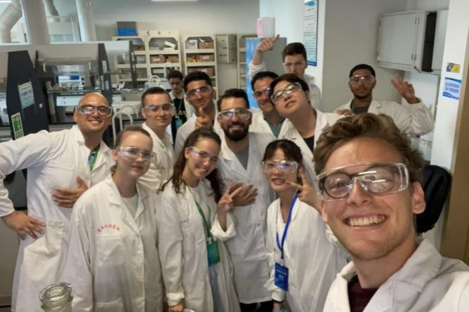

招收专业及学制
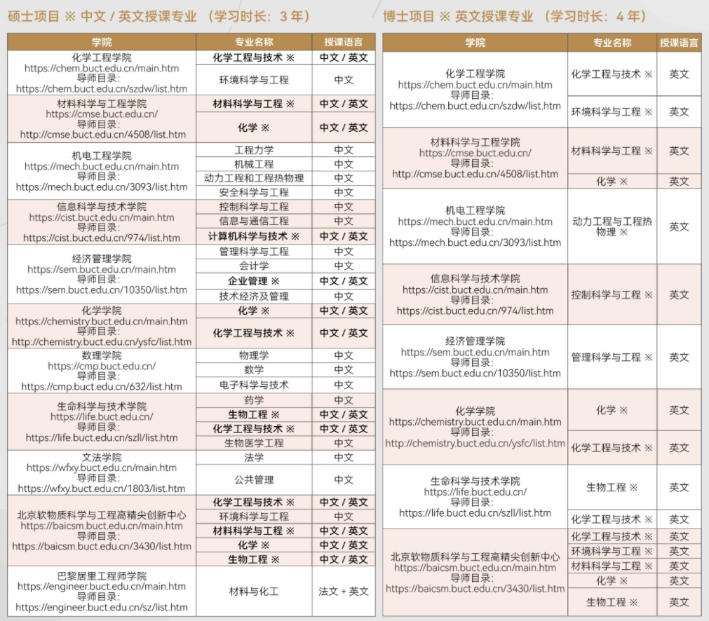

申请资格
1. 身心健康，愿意遵守中国相关法律法规和学校规章制度并持有外国有效因私护照的非中国籍公民；
2. 申请攻读硕士学位者，应当具有学士学位或同等学力，学习成绩优秀，年龄一般不超过35周岁；
3. 申请攻读博士学位者，应当具有硕士学位或同等学力，学习成绩和研究能力优秀，年龄一般不超过40周岁；
4. 语言成绩：
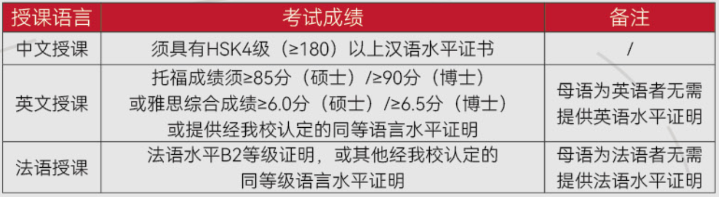
5. 华裔申请者需符合教育部教外函[2020]12号文件规定。

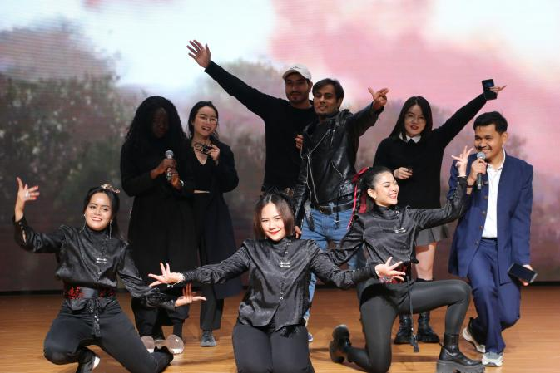

申请材料
1. 个人简历、个人陈述和研究计划（相关模板见北化申请系统中的下载专区）；
2. 护照（照片页）扫描件和中国签证页扫描件（如有）；
3. 经公证的最高学历证明/在学证明（中文或英文）；
4. 经公证的成绩单（本科及以上阶段，中文或英文）；
5. 两封推荐信（教授或副教授开具）；
6. 北京化工大学外国留学生研究生导师接收函（模板见下载专区）；
7. 外国人体格检查表；
8. 汉语或法语或英语水平证明；
9. 无犯罪记录证明（需前往当地警察局开具）；
10. 学术出版物、专利和其他学术成果的原件或扫描件（如有则优先考虑）；
11. 其他支撑材料。

注：
1. 申请者需提供北京化工大学导师接收函，并上传至申请系统。否则申请者不能成为候选人。
2. 申请者可通过以下网址获得导师详细信息： https://english.buct.edu.cn/ 点击[Faculty]；搜索学院名称。
3. 申请人必须上传上述所有材料，否则将不被视为候选人。
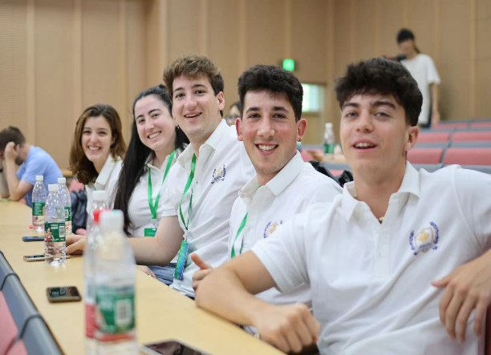

申请及录取流程

申请截止日期2026年6月30日

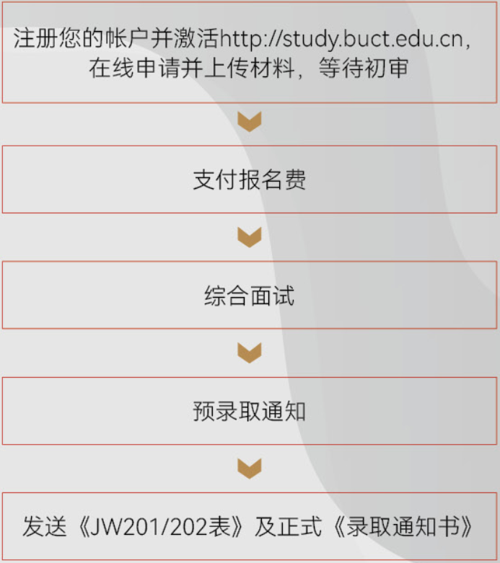

注：提交申请后请持续关注电子邮箱和申请平台。

相关费用

报名费：500人民币/人次

保险费：800人民币/年

居留许可：400人民币/年（由出入境管理局收取费用）

学费：30000人民币/年（硕士中文授课）；35000人民币/年（硕士英文授课）；35000人民币/年（博士英文授课）

住宿费：朝阳校区：双人间 10800人民币/学期，21600人民币/学年；

昌平校区：双人间 10800人民币/学期，21600人民币/学年；单人间 12600人民币/学期，25200人民币/学年。

费用缴纳

申请人需银行转账支付费用，报名费收取后，不予退还。仅支持人民币汇款，不接受外币汇款。如收到外币汇款将不予处理，由申请人自行承担损失。

缴费信息

银行户名：北京化工大学

开户银行：北京银行樱花支行

账号：01090504300120105029689

联行号：313100000273

银行转账须附言注明“硕士/博士外国留生报名费/学费+国籍+申请者护照上的姓名”

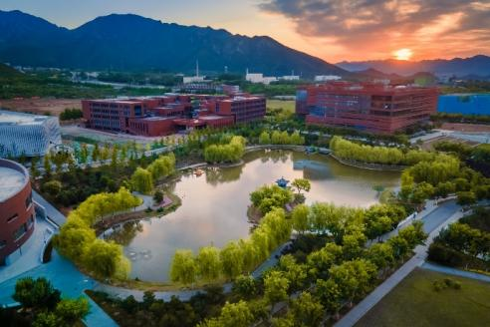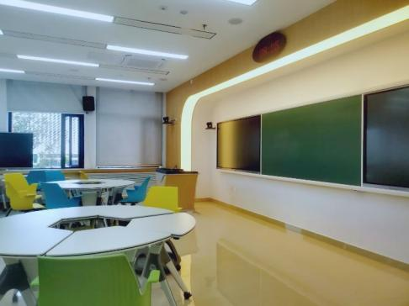

奖学金类别
中国政府奖学金
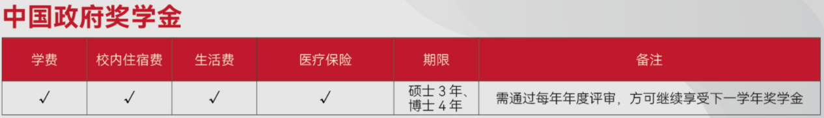

奖学金包括哪些内容?
1) 学费和校内住宿费；
2) 生活费：硕士3000人民币/月，博士3500人民币/月；
3) 综合医疗保险费用800人民币/年。

如何申请？

1）国别项目(Type A)根据中国与有关国家政府和机构等签订的合作与交流协议或达成的共识提供的奖学金，申请人向所在国有关派遣部门提出申请——中国政府奖学金A类
注: CSC申请通常在每年11月开始，具体申请日期请联系相应的机构(大使馆或外交部)。填写《中国政府奖学金申请表》时，选择Type A，并在“申请院校”一栏的第一志愿填写“北京化工大学”（北京化工大学机构代码是10010）。
- 中国院校自主招生项目(Type B)包括“高水平研究生”项目、“丝绸之路”项目等全额奖学金内容——中国政府奖学金B类申请人必须透过以下两个网站递交申请：
① 北京化工大学网上申请系统http://study.buct.edu.cn
② CSC申请系统https://studyinchina.csc.edu.cn (北京化工大学机构代码是10010)。

北京化工大学校长奖学金（仅针对博士申请者）
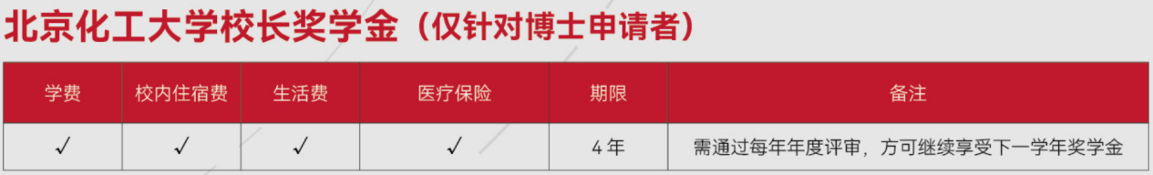

奖学金包括哪些内容?
1) 学费和校内住宿费；
2) 生活费：硕士3000人民币/月，博士3500人民币/月；
3) 综合医疗保险费用800人民币/年。

如何申请？
在http://study.buct.edu.cn注册账号并激活，在线填写申请表，北京化工大学将根据申请材料组织评估。
注：北京化工大学校长奖学金项目只招收博士研究生。

奖学金截止日期
2026年3月 中国政府奖学金
2026年6月 北京化工大学校长奖学金

注意：
•奖学金竞争非常激烈，越早申请的候选人越有优势。
•您的因私护照需在2026年9月报到时仍在有效期内。
•请在提交申请时准确填写您的个人信息，申请姓名、出生日期、护照号等需与护照首页完全一致以便顺利获得录取通知书。
•若学生无法来华，学费、住宿费、生活费奖学金暂停。

联系方式
地址：北京市朝阳区北三环东路15号北京化工大学国际教育学院留学生办公室
邮编：100029
电话：+86（010）64452461
邮箱：buctapply@buct.edu.cn
网址：https://www.buct.edu.cn/main.htm

Study in BUCT

School of International Education

