2026国际学生本科生招生简章

ADMISSION BOOK FOR INTERNATIONAL STUDENTS
UNDERGRADUATE PROGRAMS

Introduction to Beijing University of Chemical Technology
Founded in 1958, Beijing University of Chemical Technology (BUCT) is a national key university affiliated with the Ministry of Education of the People’s Republic of China. A member university of China's "211 Project", "985 Project Innovation Platforms" and “Double First-Class University Project". BUCT shoulders the mission of innovative talent training, scientific research, and high-tech development.
Over the past 68 years, through continuous efforts, BUCT has grown into a comprehensive multidisciplinary university rooted in science and engineering and enriched by distinctive disciplines such as business, economics, law, literature, philosophy, education, and medical science. It offers a complete talent development pathway from undergraduate to doctoral levels. In the Essential Science Indicators (ESI) rankings, chemistry, material science and engineering are among the top 1‰ in the world, computer science, environment/ecology, biology/biochemistry, geoscience, agricultural science, physics, Pharmacology & Toxicology, top 1%. The scientific research of BUCT has been in robust development in recent years. Its science and technology funds continue to hit record highs.
With 18 colleges and schools, BUCT is the home university of 16,000 full-time undergraduate students, 10400 full-time postgraduate students (including 2,000 PhD students), 2,700 students of continuing education, and around 400 international students. It hosts more than 2,700 faculty members and staff including 8 academicians from the Chinese Academy of Science and the Chinese Academy of Engineering and 5 international academicians.
With a global vision, BUCT has successively established partnerships with over 170 institutions all over the world. It offers a wide range of education programs to international students including bachelor's, master's and doctoral programs in Chinese and English, Chinese language and culture programs, and summer science camps. It runs around 90 study abroad programs, including exchange programs, joint degree programs, overseas training programs and summer/winter camps. BUCT constantly supports international research collaborations, which have generated abundant high-level research publications in top academic journals. It also hosts a wide range of international conferences and competitions.
The 21st century presents both unprecedented opportunities and profound challenges. Upholding its motto — “to be ambitious, virtuous, profoundly learned, and to serve people” — BUCT is committed to becoming a world-class university distinguished by its unique character and global influence.

Undergraduate Programs
Duration: 4 years
※: Provide English Taught Programs
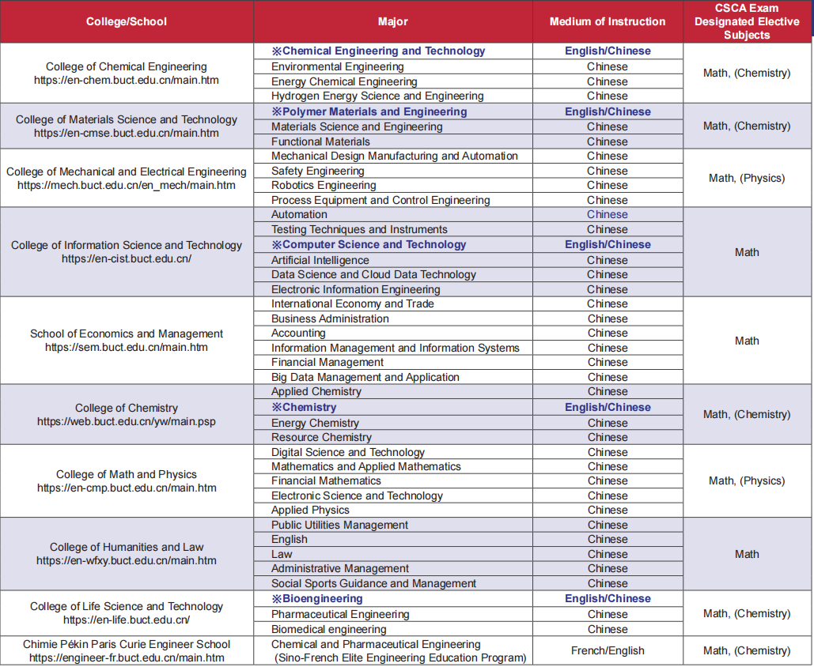

Qualifications of Applicants
• High-school graduate (or above) who is qualified to apply to universities.
• Be a non-Chinese citizen holding a valid ordinary (private) passport, and agree to observe the laws of China and the regulations of BUCT.
• Aged between 18 to 25; Applicants under 18 must provide certificate of guardian who has Beijing residency.
• Applicants with Chinese background must comply with the regulation (JW[2020]No.12) issued by Ministry of Education of the People’s Republic of China.

Application Procedure (Deadline: 30 June 2026)
• Register an account and activate: http://study.buct.edu.cn，fill out necessary details and upload required materials;
• Pay the application fee (CNY 500) after passing preliminary examination;
• Academic Proficiency Test (Online);
• Comprehensive interview;
• Pre-admission Announcement (Accepted applicants will be informed via Email);
• Receive the Admission Letter and JW201/JW202 Visa Application form.
Note：Please check your email and application platform regularly after submission.

Admission Materials
• Curriculum Vitae and Study Proposal (Relevant templates can be found in the Download Section of the BUCT application system);
• The Photo copy of a valid private Passport Photo Page and China Visa Page (If you have);
• Certified/notarized high-school transcript (Chinese or English);
• Certified/notarized high-school Diploma (Chinese or English;
• Language certificate (per program requirements);
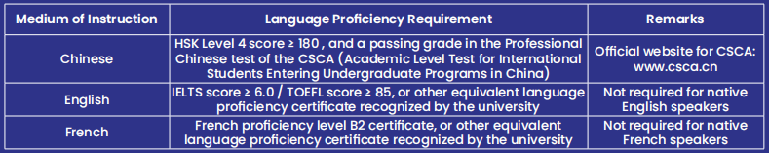
• CSCA designated elective subject scores (Refer to the table on the previous page);
• Foreigner Physical Examination Form, download from application platform;
• No Criminal Record Certificate;
• Applicants under 18 must provide notarized guardianship documents for a guardian who resides in Beijing.

Fees
Application Fee: CNY 500/person
Insurance Fee: CNY 800/year
Residence Permit Charge: CNY 400/year (It is collected by Immigration Bureau)
Tuition fees: Undergraduate Students: CNY 20000/year

Accommodation:
Chaoyang Campus: Double room CNY 10,800/semester (CNY 21,600/year, per person)
Changping Campus: Double room CNY 10,800/semester (CNY 21,600/year, per person); Single room CNY 12,600/semester(CNY 25,200/year)

Fee Payment
Notice: Applicants need to pay the fees by bank transfer. The application fee and tuition fee deposit are not refundable after being collected. Only Chinese CNY remittance is accepted, foreign currency remittance is not accepted. Any remittance received in foreign currency will not be processed and will be at the applicant's own risk.

Payment information
Account name: Beijing University of Chemical Technology
Bank: Bank of Beijing Yinghua Branch
Account number: 01090504300120105029689
Correspondent number: 313100000273
Bank transfer should be accompanied by “Bachelor Application Fee/Tuition Fee + Nationality + Applicant's passport name”

Scholarships
Chinese Government Scholarship (Type A)
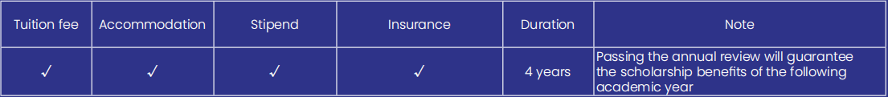
Note: Scholarship will be suspended if students cannot study on-campus.

How to apply?
1) The scholarship application is directed to the local Chinese Embassy or consulate. The application time is usually from November to April next year. Please ask for more application information from Chinese Embassy/Consulate in your home country.
2) When filling in the scholarship application form, the applicant should choose Type A and select Beijing University of Chemical Technology as the first priority institution (The institution code for BUCT is 10010).

Applicants must submit their applications through the following two websites:
① Beijing University of Chemical Technology Online Application System: http://study.buct.edu.cn
② CSC Application System: https://studyinchina.csc.edu.cn (The institution code for BUCT is 10010).

Beijing Government Scholarship for International Students
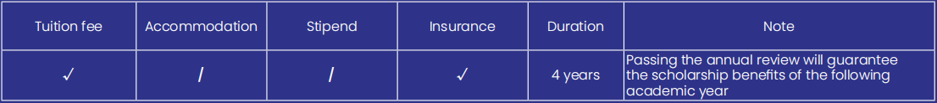
How to apply?
• Register an account and activate in http://study.buct.edu.cn, fill out your application online, BUCT will evaluate applications based on the submitted materials.

Scholarship Deadlines
Normally in March /2026 ----- Chinese Government Scholarship Type A
(For more details, please contact the Chinese Embassy in your country)
• June/2026 ------ Beijing Government Scholarship for International Students in China (https://english.beijing.gov.cn/studyinginbeijing/index.html)

Note:
• Scholarships are highly competitive and more beneficial for those candidates who apply for it in an early time.
• Your private passport must remain valid until at least September 2026 when reporting for enrollment.
• Please be accurate your personal details when submit the application. The applicant's name, date of birth, passport number, and other details must exactly match the information on the ID page of the passport in order to get the offer smoothly and successfully.

Contact
International Students Office, School of International Education Beijing University of Chemical Technology
No. 15 Bei San Huan East Road, Chaoyang District, Beijing, 100029
Phone: 0086-10-64452461
Email: buctapply@buct.edu.cn
Website: https://english.buct.edu.cn/ English version
Facebook: 北京化工大学 Beijing University of Chemical Technology - BUCT
Instagram: buct.apply
WhatsApp: +86 18811406750
X: BeijingChemical

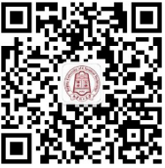 Study in BUCT

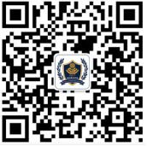 School of International Education



2026国际学生本科生招生简章

ADMISSION BOOK FOR INTERNATIONAL STUDENTS
UNDERGRADUATE PROGRAMS

北京化工大学简介
北京化工大学创办于 1958 年，原名北京化工学院，是新中国为“培养尖端科学发展所需的高级化工技术人才”而创建的一所高水平大学。作为教育部直属的全国重点大学，国家“211 工程”和“‘985’优势学科创新平台”重点建设院校，国家“双一流”建设高校，北京化工大学肩负着高层次创新人才培养和基础性、前瞻性科学研究以及原创性高新技术开发的使命。
经过 68 年建设发展，学校形成了“宏德博学、化育天工”的校训和“团结奉献、艰苦奋斗、务实力行、博学创新”的化大精神。目前，学校已发展成为一所理科基础坚实，工科实力雄厚，管理学、经济学、法学、文学、教育学、哲学、医学等学科富有特色的多科性重点大学，形成了本科教育、研究生教育、国际学生教育、继续教育等多层次人才培养格局。现有 18 个院（系），在校全日制本科生 16000 余人，研究生 10400 人（其中博士 2000 余人），函授、夜大等继续教育学生 2700 余人，学历留学生近 400 人。教职工 2700 多名，其中包括 8 名中国科学院院士和中国工程学院院士及 5 名国际院士。
学校学科实力稳步增强，“化学工程与技术”入选国家“双一流”建设学科，在国家第五轮学科评估中 A类学科取得显著突破。化学、材料科学、工程学居 ESI 排名前 1‰，化学、材料科学、工程学、生物学与生物化学、生态 / 环境学、计算机科学、农业科学、地球科学、物理学、药理学与毒理学等 10 个学科位列 ESI 排名前 1%。
北京化工大学与全球 170 余国外机构建立了合作伙伴关系，为国际学生提供多种教育课程，包括中英文学士、硕士和博士课程、中国语言和文化课程以及暑期科学营。

本科专业介绍
※ 中文 / 英文授课专业 （学习时长：4 年）
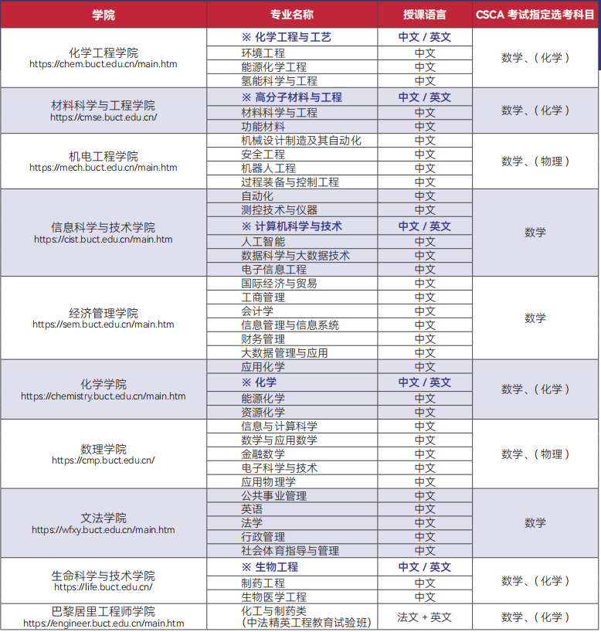

申请资格
• 高中毕业或以上学历，具备大学申请资格。
• 身心健康，愿意遵守中国相关法律法规和学校规章制度并持有有效因私护照的非中国籍公民。
• 年龄满18岁至25岁之间，未满18岁需提供在中国北京的监护人材料。
• 华裔申请者需符合教育部教外函[2020]12号文件规定。

申请材料
• 个人简历和个人陈述（相关模板见北化申请系统中的下载专区）；
• 护照（照片页）扫描件和中国签证页扫描件（如有）；
• 高中成绩单（需公证，需中文或英文版本）；
• 高中毕业证（需公证，需中文或英文版本）；
• 语言成绩：
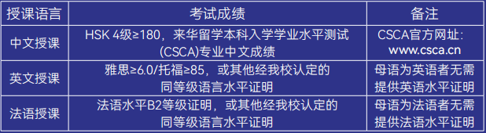
• 来华留学本科入学学业水平测试（CSCA）成绩单；
• 外国人体格检查表；
• 无犯罪记录证明（需前往当地警察局开具）。

申请及录取流程
截止日期2026年6月30日（CSC高水平研究生奖学金2026年3月30日截止）
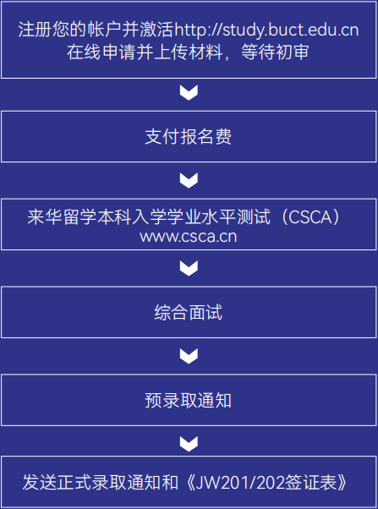
注：提交申请后请持续关注电子邮箱和申请平台。

相关费用
报名费：500人民币/人次
保险费：800人民币/年
居留许可：400人民币/年（由出入境管理局收取费用）
学费：20000人民币/年
住宿费：
朝阳校区：双人间 10800人民币/学期，21600人民币/学年；
昌平校区：双人间 10800人民币/学期，21600人民币/学年；单人间 12600人民币/学期，25200人民币/学年
费用缴纳
申请人需银行转账支付费用，报名费收取后，不予退还。仅支持人民币汇款，不接受外币汇款。如收到外币汇款将不予处理，由申请人自行承担损失。
缴费信息
银行户名: 北京化工大学
开户银行: 北京银行樱花支行
账号: 01090504300120105029689
联行号: 313100000273
银行转账须附言注明“本科外国留生报名费/学费+国籍+申请人护照上的姓名”

奖学金类别
中国政府奖学金（A类）
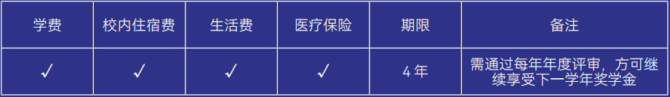
如何申请？
通过中国驻申请者所在国大使馆或总领事馆申请中国政府奖学金。
使领馆接受申请的时间一般是每年11月至次年4月，请注意提前查询。填写《中国政府奖学金申请表》时，选择Type A，并在“申请院校”一栏的第一志愿填写“北京化工大学”（北京化工大学机构代码是10010）。
申请人必须通过以下两个网站递交申请:
① 北京化工大学网上申请系统 http://study.buct.edu.cn
② CSC申请系统 https://studyinchina.csc.edu.cn (北京化工大学机构代码是10010)。

北京来华留学生政府奖学金
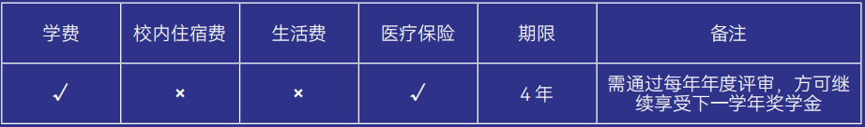
如何申请？
在http://study.buct.edu.cn注册账号并激活，在线填写申请表，北京化工大学将根据申请材料组织评估。
奖学金截止日期
2026年3月—中国政府奖学金 Type A（详情请向中国驻贵国大使馆查询或者教育部）
2026年6月—北京来华留学生政府奖学金（https://english.beijing.gov.cn/studyinginbeijing/index.html）
注意：
1. 奖学金竞争非常激烈，越早申请的候选人越有优势；
2. 您的因私护照需在2026年9月报到时仍在有效期内；
3. 请在提交申请时准确填写您的个人信息，申请姓名、出生日期、护照号等需与护照首页完全一致，以便顺利获得通知书；
- 若学生无法来华，奖学金暂停。

联系方式
地址：北京市朝阳区北三环东路15号北京化工大学国际教育学院留学生办公室
邮编：100029
电话：+86（010）64452461
邮箱：buctapply@buct.edu.cn
网址：https://english.buct.edu.cn/

Study in BUCT

School of International Education

